Practical - 3

Task - 1:
Compilation and Execution:
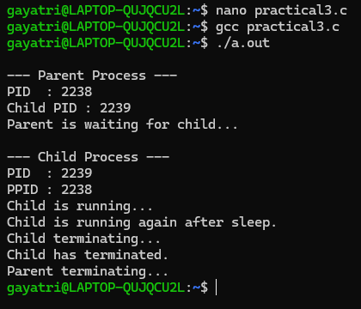

Task - 2:
ps command:
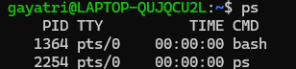

top command:
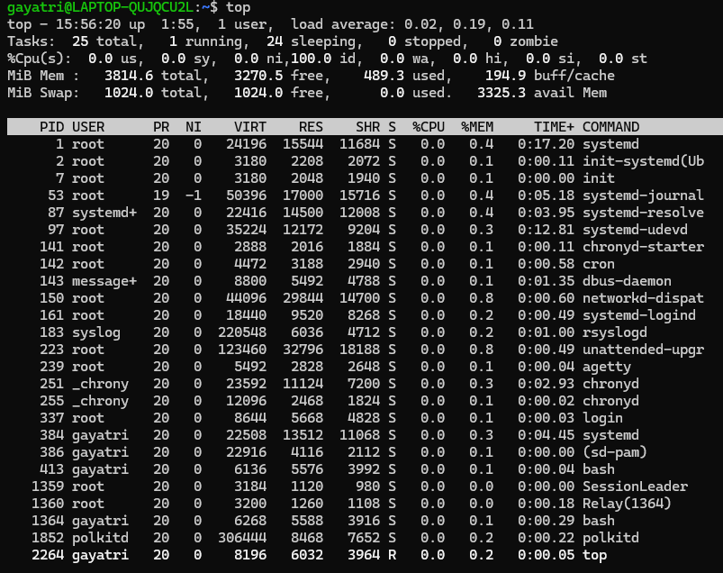

/proc command:
